

g

IBM Security QRadar SOAR
Add-on for Splunk User Guide
V2.4.1



Date: December 2024

Licensed Materials – Property of IBM
© Copyright IBM Corp. 2010, 2024. All Rights Reserved.
US Government Users Restricted Rights: Use, duplication or disclosure restricted by GSA ADP Schedule Contract with IBM Corp.

IBM Security QRadar SOAR
Add-on for Splunk User Guide
Version | Publication | Notes
2.4.1 | April 2026 | Enterprise Security 8.3.0 support workaround
2.4.0 | February 2026 | Update splunklib version to 2.1.1
2.3.0 | December 2024 | Secure connection to SOAR is required starting with 2.3.0: On Setup Page, Connect Securely checkbox is replaced with a text box requiring user to enter true when using a CA certificate or the path to a self-signed certificate.  Write json files to /local/data directory.  Fix Python 3.9 issue with json.loads encoding parameter.  Write “success” action status for each result processed.  Update splunklib to 2.1.0.
2.2.0 | October 2024 | Add support for SOAR custom artifact types when mapping search results to artifacts in SOAR case.  Update splunklib to 2.0.2.  Remove request-toolbelt from the Add-on.
2.1.1 | May 2024 | Fix bug setting custom fields to null when updating existing SOAR case with the same splunk_notable_event_id.
2.1.0 | April 2024 | Update splunklib to 1.7.4.  Update requests-toolbelt to 1.0.0.
2.0.0 | June 2022 | Rebranded add-on to:  IBM Security QRadar SOAR Add-on for Splunk.  Folder name changed to SA_QRadar_SOAR.  Add SOAR case URL to Splunk ES History.  Update splunklib to 1.6.20.
1.3.2 | June 2022 | Bug fix related to $ character in result tokens.
1.3.1 | May 2022 | Bug fix: Escape special characters in search result tokens.
1.3.0 | November 2021 | Support for creating multiple add-on instances via shell script.  Use single quotes around multiselect fields containing commas.  Use html format for incident description field.  Max Artifacts Per Alert limit set to 99 on the Set up page.  User Guide updates for Cloud Pak for Security and SaaS.
1.2.2 | March 2021 | Setup UI patch.  Bug fix related to artifacts.
1.2.1 | February 2021 | Splunk Cloud compliance.
1.2.0 | December 2020 | Support for Resilient API keys.  Ability to update an existing incident from Splunk ES.  Permission for ess_analyst role to use the add-on.
1.1.0 | August 2020 | Added support for Python 3.
1.0.2 | April 2018 | Updated Splunk version number.
1.0.1 | January 2018 | Initial publication.

Table of Contents
Overview 5
Installation 6
Requirements 6
Installation and Setup 6
Configuration 7
Escalating Splunk Alerts 9
Adding a Splunk Alert Action 9
Mapping Date and Datetime Fields 10
Mapping Multiselect Fields 10
Mapping Multiple Artifacts of the Same Type 11
Updating the Default Case Mapping 11
Escalating Splunk ES Notable Events 12
Adding an Adaptive Response Action 12
Ad Hoc Invocation 14
Show Escalated Notable Events 16
Mapping Additional Fields 16
Mapping Date and Datetime Fields 17
Mapping Multiselect Fields 17
Mapping Multiple Artifacts of the Same Type 19
Mapping event_id for Notable Events 19
Updating the Default Case Mapping 20
Troubleshooting 21
Setup Screen 21
Case Not Created 21
Ad Hoc Invocation Failure 22
Splunk Enterprise Security 8.3.0 Compatibility…………………………………………………………………………………………….23
Support 25

Overview
The IBM Security QRadar SOAR Add-on for Splunk supports Splunk and Splunk ES. The add-on provides the capability of escalating a Splunk alert or Splunk ES notable event to a SOAR case, also called an incident.
The SOAR Add-on features include:
- Easy Case Mapping: Enables mapping of static values or search result tokens into custom fields in a SOAR case. You can map fields parsed from the event in the alert or notable event directly into any field. You also have custom case mapping rules for each saved alert or notable event.
- Create Artifacts: Maps result tokens into artifacts at the same time the case mapping is defined.
- Custom Field Discovery: Retrieves the case definition from SOAR so that all defined fields and field values are catalogued inside Splunk or Splunk ES. This allows you to add custom fields to SOAR, which are then available for mapping in Splunk or Splunk ES.
- Automatic and manual escalation: Escalates notable events from a correlation search or alerts from a saved search to SOAR cases (automatic escalation). For Splunk ES only, you can escalate notable events as an ad hoc action (manual escalation).

A Conversion Script package converts an instance of the add-on into a different instance with a user specified name. You can import the new instance into an on-premises Splunk installation and configure it to run with a different SOAR organization or platform. The package can be downloaded from the IBM App Exchange.

Installation

Requirements
The following lists the system requirements
- Splunk version 8.0 or later.
- Splunk ES 6.1.0 or later for Python 3 support (ES 8.3.0+ supported with workaround).
- Splunk CIM Framework.
Note: The add-on depends on Splunk CIM. Install CIM before installing the add-on.
- QRadar SOAR platform version 35 or later.
- Ability to connect directly from Splunk to your QRadar SOAR platform with HTTPS on port 443.
- A dedicated SOAR Administrator or equivalent account on the SOAR platform. This can be any account that has the permission to create incidents and simulations, and view and modify administrator and customization settings. You need to know the account username and password.
or
A dedicated API key/secret pairing with equivalent permissions. This can be any API key that has the permission to create incidents and simulations, and view and modify administrator and customization settings. You need to know both the API key and secret.
Note: Should you later change the dedicated SOAR account or API key, the new credentials must also have the permission to edit incidents, in addition to the permission to create incidents and simulations and view and modify administrator and customization settings. The edit permission is necessary so that the integration can continue to modify or synchronize the incidents escalated by the original user account.
You can refer to the Playbook Designer Guide for more information about simulations.
- Splunk admin role for the user who installs and sets up QRadar SOAR Add-on for Splunk. Both the admin and ess_analyst roles may use the add-on as an Alert Action or an Adaptive Response Action for a correlation search.

Installation and Setup
If upgrading SA_QRadar_SOAR, clear your browser cache after installing the upgrade.
For Splunk Cloud and Splunk ES Cloud users, contact Splunk Support to create a ticket for installing the QRadar SOAR Add-on for Splunk.
If you have installed Splunk or Splunk ES on-premises, you can download and install the add-on from Splunkbase. Alternatively, you can request an installer from IBM QRadar SOAR.
After installing the add-on in a standalone or a search head cluster environment and restarting Splunk, navigate back to the Apps Manager screen. Click Set up in the SA_QRadar_SOAR row. Fill out the required attributes for your SOAR and click Submit. When you Submit, the Set Up program performs the following:
- Retrieves the case definition from SOAR so that all fields, including custom fields, are catalogued.
Note: If a SOAR administrator adds custom fields after you run Set up, you need to run Set up again to capture the new fields.
Note: If running in a search head cluster environment, Set up needs to be executed on one search head member only. Set up information is replicated to each of the other search head members after hitting Submit with successful completion.
- Tests the configuration to verify that the connection is successful. If the configuration saves successfully, you are up and running.
Refer to the Troubleshooting section if you encounter a problem.

Configuration
Configure the QRadar SOAR Add-on for Splunk to access your SOAR on the Setup Page pictured below. Navigate to this page from the Apps Manager screen.

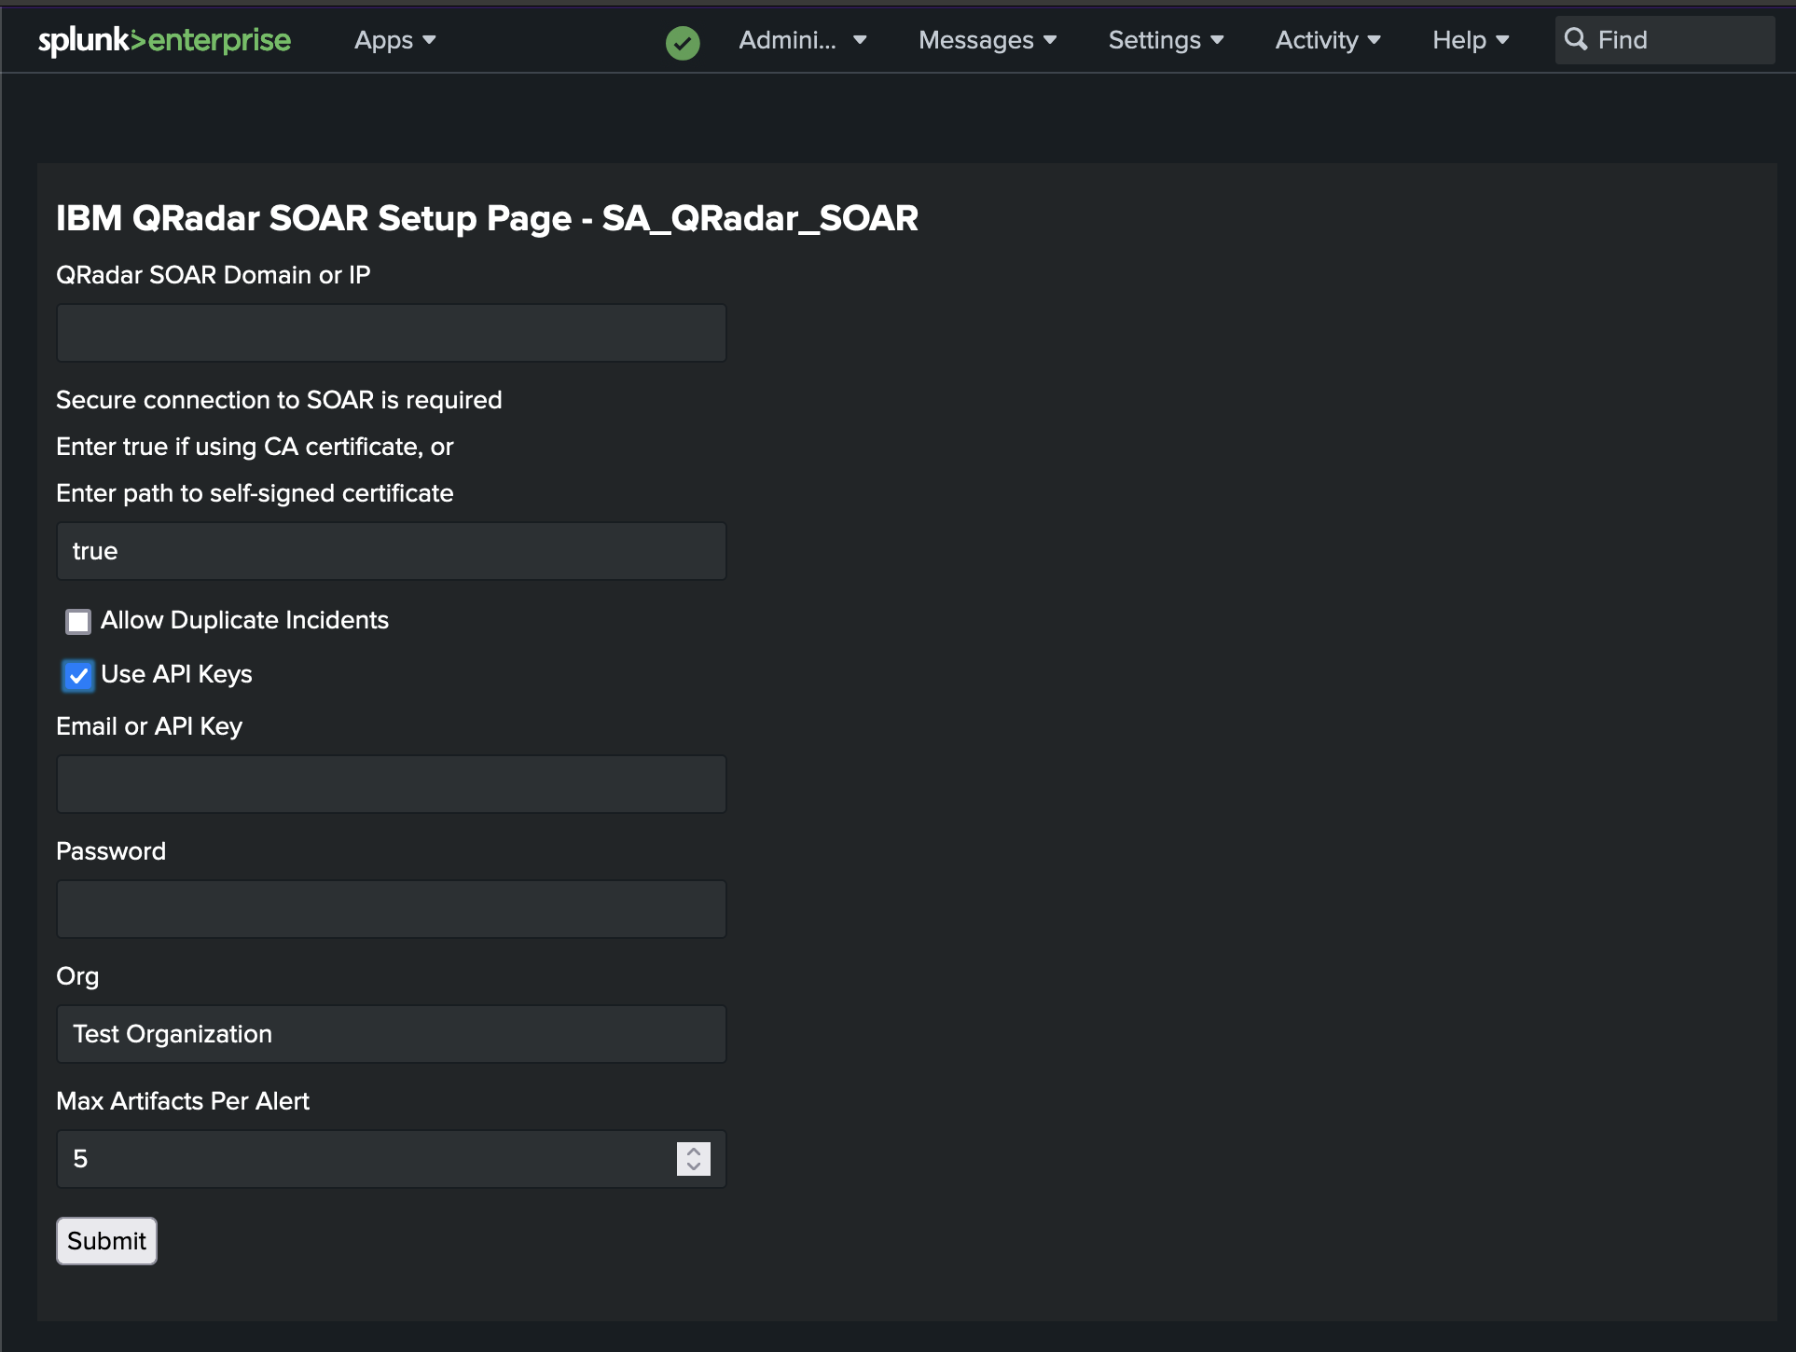

Guidelines for configuring the Set Up Page parameters:
- QRadar SOAR Domain or IP: Hostname or IP for your SOAR. Do not include the https:// prefix.
Note: If configuring for Cloud Pak for Security, prefix the hostname with cases-rest.
For example: cases-rest.cp4s-domain.com
If configuring for Cloud Pak for Security SaaS, contact CP4S SaaS Support for the cases rest and stomp endpoints.
For DNS Mapping, the user should save the IP and domain name in the file /etc/hosts on the Splunk server.
- Certificate Configuration: Enter true if using a CA certificate or the absolute path to a self-signed certificate.
- Allow Duplicate Incidents: If unchecked, the add-on searches for an existing open case or incident in SOAR and, if found, updates that case. If there is no match, a new case is created. If this box is checked, a new case is created every time the action is triggered.
Note: Updating existing cases or incidents in SOAR requires use of Splunk ES and the splunk_notable_event_id custom field. See Mapping event_id for Notable Events.
- Use API Keys: Check to authenticate with SOAR using an API key and secret. Uncheck to authenticate with SOAR using an email and password.
Note: If configuring for Cloud Pak for Security, API key must be used.
- Org: The name of the SOAR organization.
Note: If configuring for Cloud Pak for Security, the Org name must be in UUID format.
- Email or API key: Email address or API key ID you use when authenticating with SOAR.
Note: If configuring for Cloud Pak for Security, API key must be used.
- Password: Password for the SOAR account or API key secret for the SOAR API key. This is a mandatory field, and the value must be entered before clicking Submit.
- Max Artifacts per alert: Maximum number of artifacts you may need to map into a single SOAR case from any given Splunk alert or Splunk ES notable event. This field takes an integer.
Note: Wait a few moments after clicking Submit to allow the setup process to complete. Your browser displays a pop-up dialog with the results of the setup process when completed. Once you have successfully configured the add-on, the setup page displays the last successful configuration in the form, except for Password, which you must enter.

Escalating Splunk Alerts

Adding a Splunk Alert Action
To add a SOAR escalation to an alert, go to the Alerts tab in the Search & Reporting app and find the alert for which you want to create a SOAR case. Click Edit and select Edit Actions. Click + Add Actions and select Create QRadar SOAR Case (SA_QRadar_SOAR). Update the fields to indicate how you want them mapped. You can use static values or tokens from the alert data. In addition to the fields parsed in your particular alert search, the Splunk documentation has a list of the default tokens available in any search.
Be sure to map a valid value for the Date Discovered field, which is always required.
A sample alert, failed_splunk_login_send_to_qradar_soar, is included. If you enable this alert, a SOAR case is created each time there is a failed login attempt to Splunk. If you have added custom required fields to your SOAR, you need to edit the mapping on the alert action screen to include them before triggering the example.
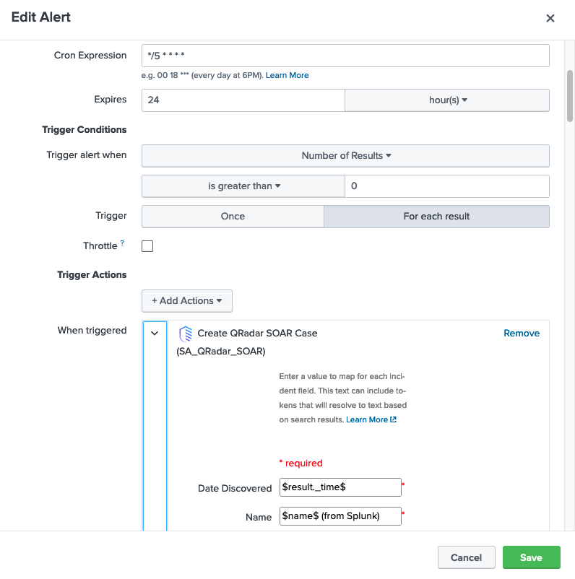

Mapping Date and Datetime Fields
If mapping values from Splunk to Date Picker or Date Time Picker fields in SOAR, the formatting of those values in the mapping must meet certain requirements. If you are parsing the date/datetime value from the Splunk search using a token, the value is already properly formatted and there is no additional action required. However, if you are providing a static value for the mapping, dates must be formatted as YYYY/MM/DD. Similarly, datetime values must be provided as YYYY/MM/DD HH:MM:SS ±xxxx. The ±xxxx following the time is the UTC offset value. For example, the value for Cambridge, Massachusetts, United States is –0500. Be sure to include a leading zero if your offset value is a single-digit number of hours.

In Python3, you may include a colon between the hour and minute values (in the Cambridge example this is –05:00). However, in Python2 the UTC offset must be only the directional sign and exactly four digits. This value is optional when providing a static datetime. If you do not provide a UTC offset value, the datetime object is assumed to be in Greenwich Mean Time (GMT).

Mapping Multiselect Fields
If mapping values from Splunk to Multiselect field in SOAR, these values must be supplied as comma separated values (CSV). If Splunk result tokens (tokens delimited by leading and trailing $-character) are used in mapping values, no space can be specified before the comma. For example, valid value formats to map are:

- $result.value1$,$result.value2$,$result.value3$

The following introduction of spaces generates errors when creating the case in SOAR.

- $result.value1$,$result.value2$, $result.value3$

When mapping values without Splunk result tokens, a space can be placed between the values after comma. The following are valid formats:

- 1,2,3
- 1,2, 3
- 1, 2, 3
- $result.value1$, 1, 2, 3

These examples assume that values 1, 2, 3 and the values returned from Splunk after evaluating $result.value1$, $result.value2$, and $result.value3$ are valid selections for the multiselect field you desire to fill or update in SOAR. You need to define these accepted values manually.

Note: Use single quotes around any multiselect value that contains comma or special characters.

- ‘New York, NY’, ‘Los Angeles, CA’

Here is an example of a Multiselect field as defined in SOAR:

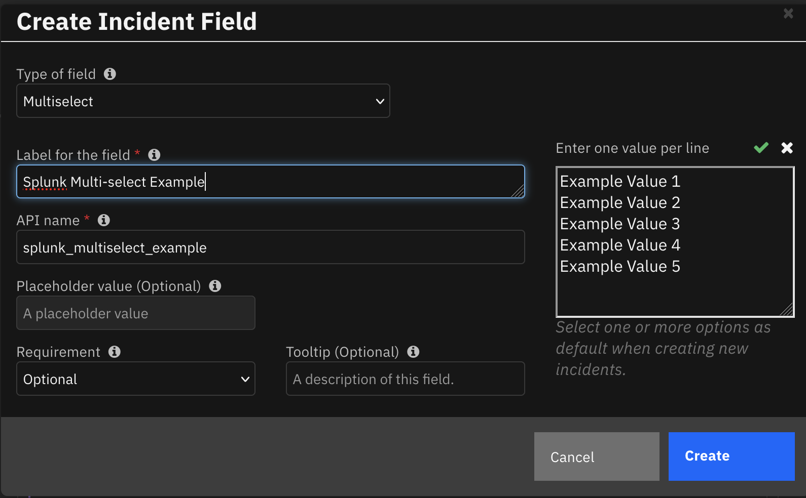

Mapping Multiple Artifacts of the Same Type
Similar to adding artifacts manually through the SOAR UI, you can add multiple artifacts of the same type at once as long as the artifact type allows multiple values. This setting can be found under Customization Settings > Artifacts in SOAR. URLs need to be separated by a space and IP addresses must be comma-separated. Artifacts can also be mapped individually.

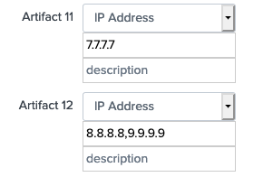

Updating the Default Case Mapping
You can change the default mapping when you configure the action. If the case mapping for most of your alerts will be very similar, you may want to override the default mapping where all the alerts start. Create an alert_actions.conf in $SPLUNK_HOME/etc/apps/SA_QRadar_SOAR/local and override the default mappings.

Escalating Splunk ES Notable Events

Adding an Adaptive Response Action
To add a SOAR escalation to a correlation search, go to the Configure tab in the Enterprise Security App, and select Content Management. Click the correlation search for which you want to create a SOAR case and scroll down to the Adaptive Response Actions section. Click + Add New Response Action and select Create QRadar SOAR Case (SA_QRadar_SOAR). Update the case fields to indicate how you want them mapped.
To create a new correlation search, go to the Configure tab in the Enterprise Security App and select Content Management. Click Create New Content and select Correlation Search. Create a new correlation. A sample correlation search failed_splunk_login_ES_send_to_qradar_soar, is included, which you can find in Content Management.
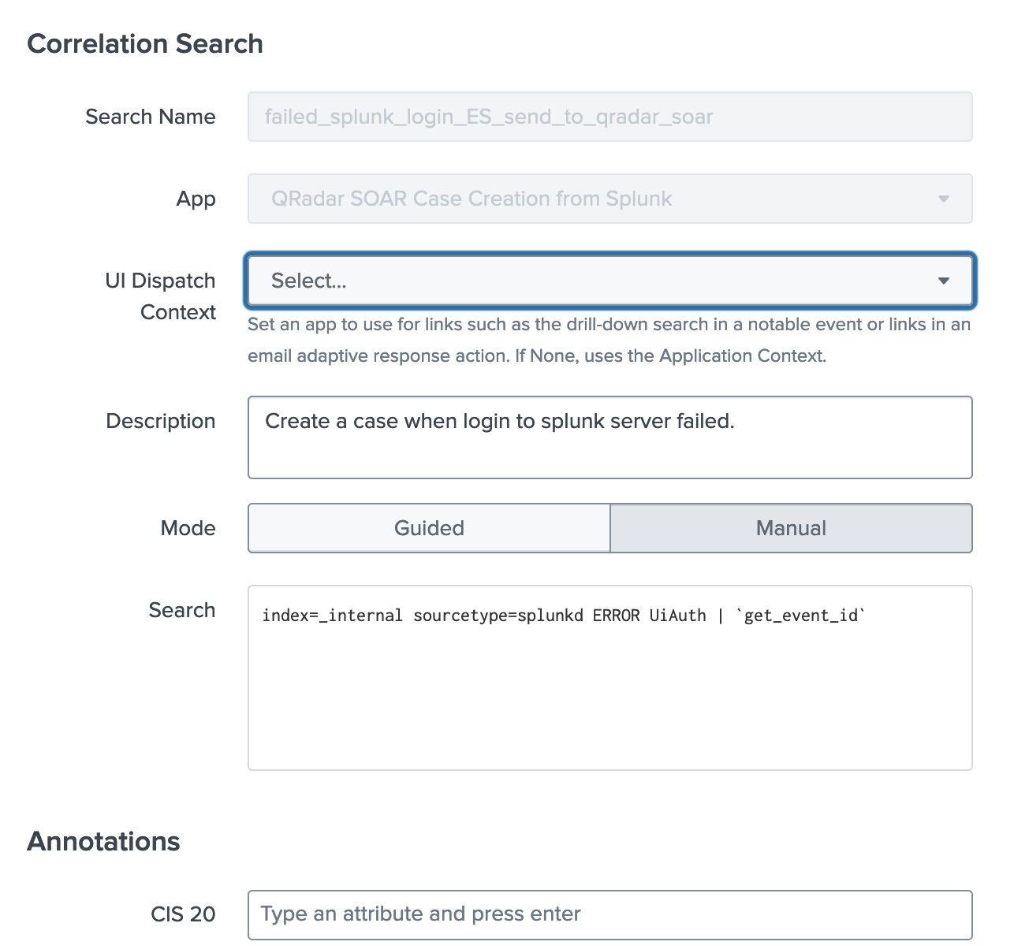
Scroll down to the Adaptive Response Actions section and view that the QRadar SOAR Add-on has been added as a response in this sample correlation search. You can change the default configuration.
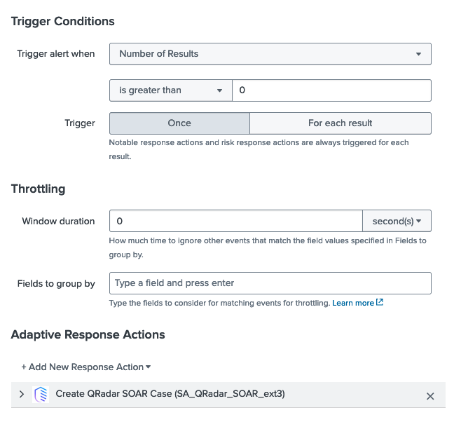

Ad Hoc Invocation
You can dispatch QRadar SOAR Add-on as an ad hoc invocation. To escalate a notable event, go to the Incident Review tab of Enterprise Security. Locate the notable event that you wish to escalate and select Run Adaptive Response Actions in the Actions column.

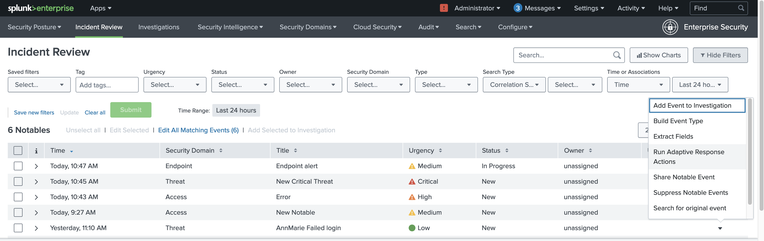
Click + Add New Response Action and select Create QRadar SOAR Case (SA_QRadar_SOAR). Update the case fields to indicate how you want them mapped.
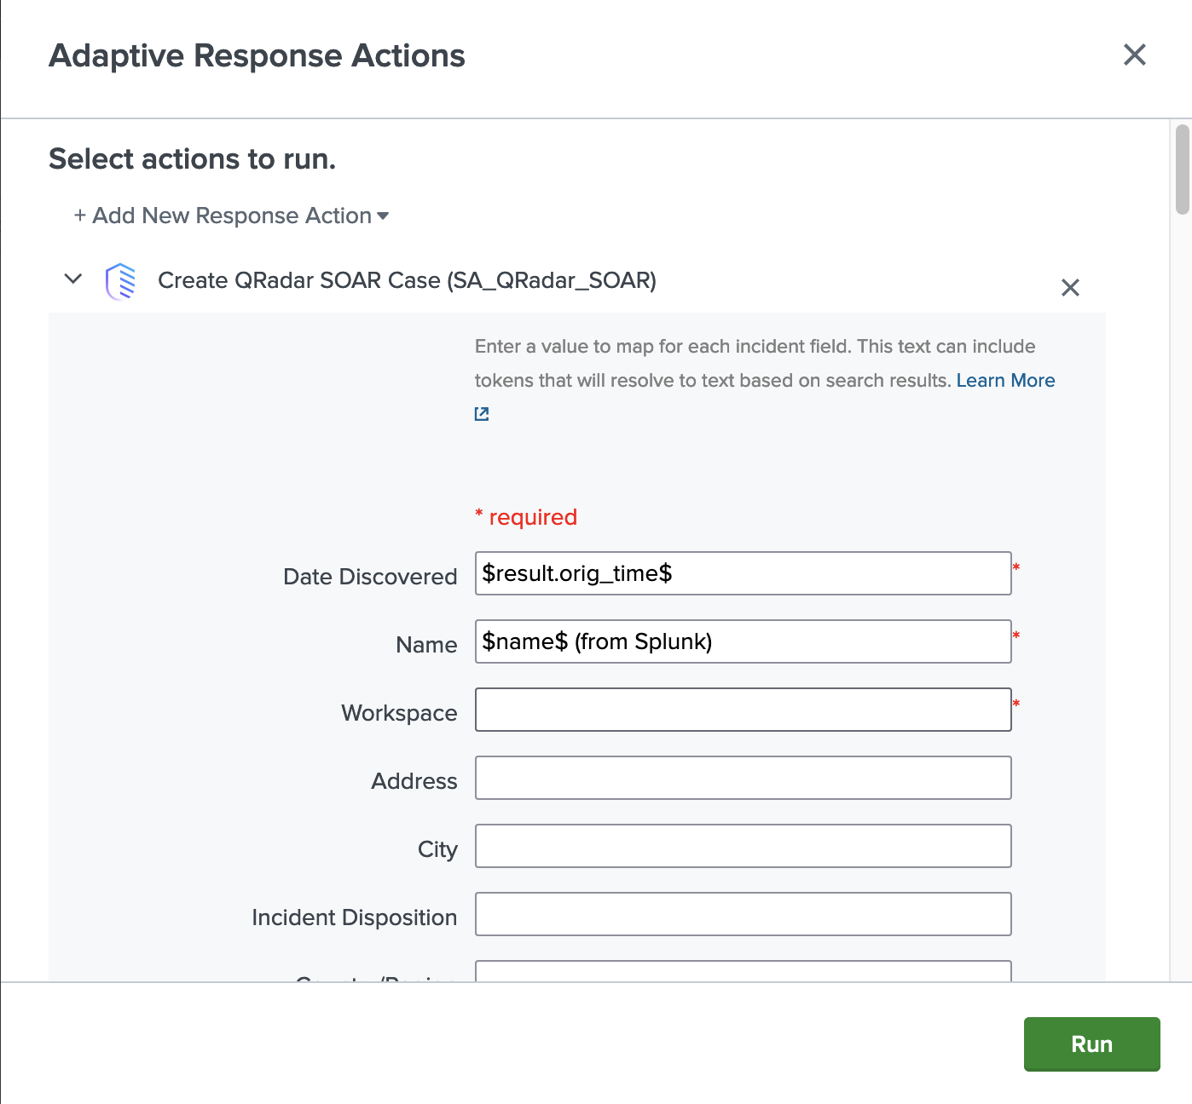

Click Run to escalate. Once completed, refresh the page to see the updated notable event. The comment contains the Case ID for the case created. The Adaptive Responses field, shown below, displays a success status for Create QRadar SOAR Case.

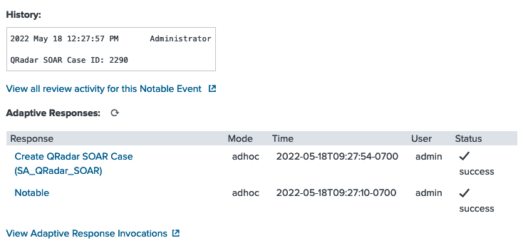

Show Escalated Notable Events
Each time a notable event is escalated successfully, the corresponding SOAR Case ID is added to the comment field of the notable event. This allows Splunk ES users to easily search for all the notable events escalated successfully. To perform a search, enter the search parameter, such as `notable` | where (comment LIKE "QRadar SOAR Case ID: %"), in the Search tab of Enterprise Security. For example:
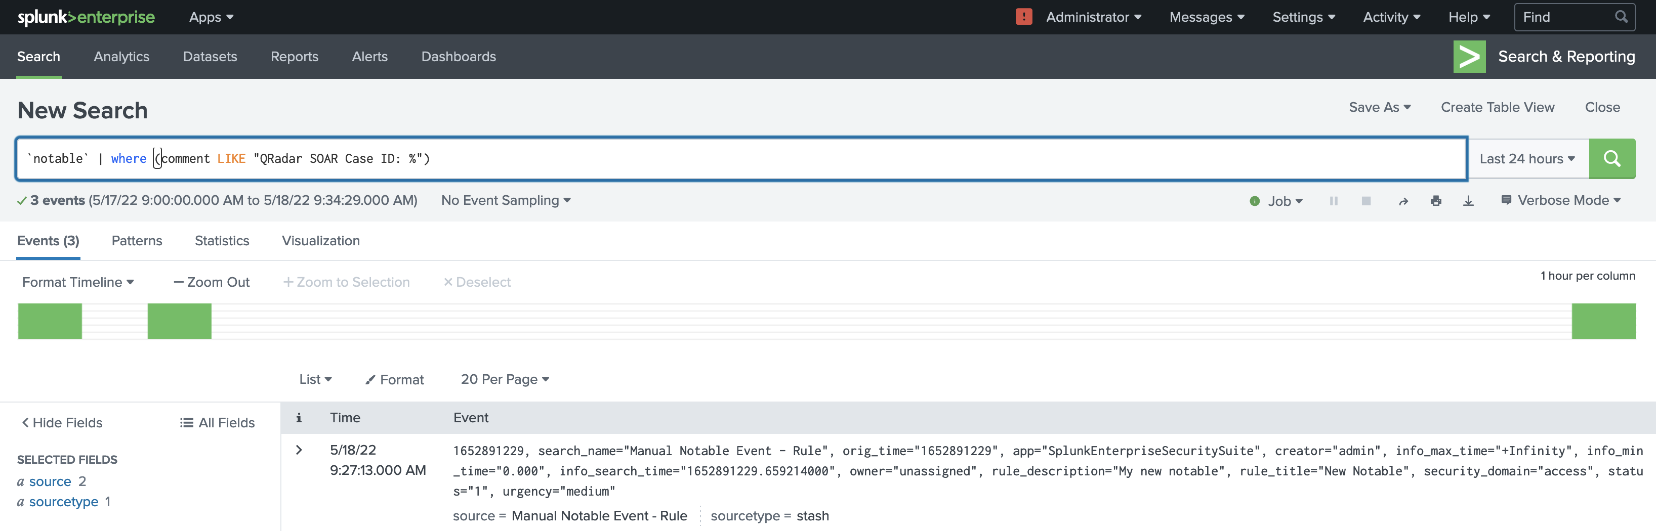

Mapping Additional Fields
You can customize Splunk ES notable events by adding additional fields, as described in the Splunk documentation. The additional fields can be used in mapping as the following token:
$result.additional_field_label$
The additional_field_label is the label used for the additional field.

Mapping Date and Datetime Fields
If mapping values from Splunk to Date Picker or Date Time Picker fields in SOAR, the formatting of those values in the mapping must meet certain requirements. If you are parsing the date/datetime value from the Splunk search using a token, the value is already properly formatted and there is no additional action required. However, if you are providing a static value for the mapping, dates must be formatted as YYYY/MM/DD. Similarly, datetime values must be provided as YYYY/MM/DD HH:MM:SS ±xxxx. The ±xxxx following the time is the UTC offset value. For example, the value for Cambridge, Massachusetts, United States is –0500. Be sure to include a leading zero if your offset value is a single-digit number of hours.

In Python3, you may include a colon between the hour and minute values (in the Cambridge example this is –05:00). However, in Python2 the UTC offset must be only the directional sign and exactly four digits. This value is optional when providing a static datetime. If you do not provide a UTC offset value, the datetime object is assumed to be in Greenwich Mean Time (GMT).

Mapping Multiselect Fields
If mapping values from Splunk to Multiselect field in SOAR, these values must be supplied as comma separated values (CSV). If Splunk result tokens (tokens delimited by leading and trailing $-character) are used in mapping values, no space can be specified before the comma. For example, valid value formats to map are:

- $result.value1$,$result.value2$,$result.value3$

The following introduction of spaces generates errors when creating the case in SOAR.

- $result.value1$,$result.value2$, $result.value3$

When mapping values without Splunk result tokens, a space can be placed between the value after comma. The following are valid formats:

- 1,2,3
- 1, 2, 3
- $result.value1$, 1, 2, 3

These examples assume that values 1, 2, 3 and the values returned from Splunk after evaluating $result.value1$, $result.value2$, and $result.value3$ are valid selections for the multiselect field you desire to fill or update in SOAR. You need to define these accepted values manually.

Note: Use single quotes around any multiselect value that contains comma or special characters.

- ‘New York, NY’, ‘Los Angeles, CA’

Here is an example of a Multiselect field as defined in SOAR:



Mapping Multiple Artifacts of the Same Type
Note: For Splunk Enterprise Security 8.3.0 users, see the "Splunk Enterprise Security
8.3.0 Compatibility" section for information about the pipe-delimited artifact format
required in the Detection Editor.
Similar to adding artifacts manually through the SOAR UI, you can add multiple artifacts of the same type at once if the artifact type allows multiple values. This setting can be found under Customization Settings > Artifacts in SOAR. URL’s need to be separated by a space and IP addresses must be comma-separated. Artifacts can also be mapped individually.



Mapping event_id for Notable Events
In SOAR, it is recommended that you create a customized field in the SOAR case for the Splunk notable event_id. In the following example, the splunk_notable_event_id of a notable event is mapped to the customized field. Refer to the SOAR Playbook Designer Guide for details.
Note: To use the update case capability and avoid creating duplicate cases, this field must have an API name of exactly splunk_notable_event_id as shown below.
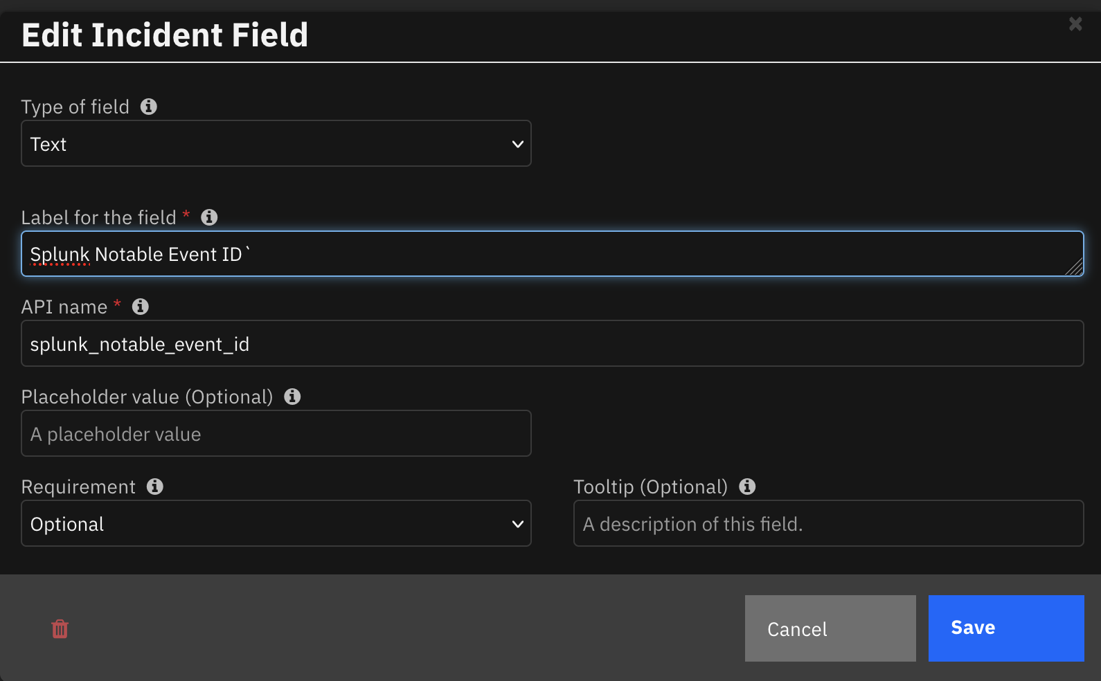

Updating the Default Case Mapping
Default mapping is provided in:
$SPLUNK_HOME/etc/apps/SA_QRadar_SOAR/default/alert_actions.conf
This default mapping includes the following tokens. The mapping also includes a hyperlink to the notable event from Splunk ES.
Field | Token
Title of the notable | $result.rule_title$
Urgency | $result.urgency$
Owner | $result.owner$
Notable description | $result.rule_description$
Status | $result.status$

The following is an example of a case created in SOAR from the mapping.
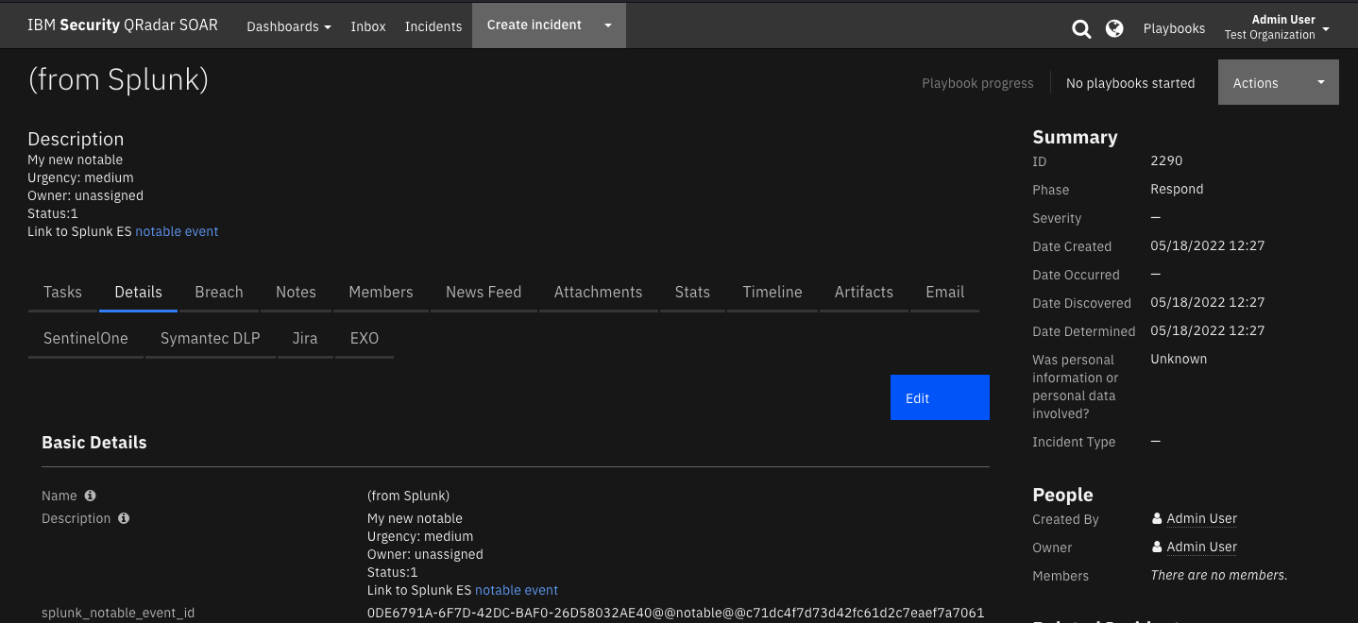
You can change the default mapping when you configure the action.

Troubleshooting

Setup Screen
When you click Submit on the QRadar SOAR Setup screen in Splunk, the app attempts to make a connection to your SOAR to verify that everything is configured correctly and to update the stored case definition. If this connection fails, you see an alert error that looks like this:

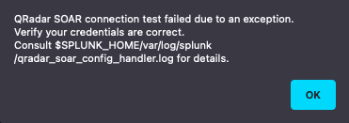

After a few seconds, the Splunk messages tab updates with detailed information about the cause of the failure.
Further information is logged to the following locations in Splunk:
- $SPLUNK_HOME/var/log/splunk/qradar_soar_config_handler.log
- $SPLUNK_HOME/var/log/splunk/splunkd.log
- $SPLUNK_HOME/var/log/splunk/python.log
Some common causes of these issues include:
- Forgot to uncheck the “Connect securely?” box for self-signed certificate.
- Port 443 is blocked.

Case Not Created
If an alert or automatic escalation for correlation search fails to create a case, a message should be logged into the Splunk messages tab informing you of the issue. Further information is logged to the following location in Splunk:
- $SPLUNK_HOME/var/log/splunk/qradar_soar_modalert.log
Some common causes of these issues include:
- Insufficient permissions to create a case, incident, or simulation.
- Missing mappings for required fields.
- Fields mapped with invalid values.
- Connection unavailable.

Ad Hoc Invocation Failure
You can view the status of an ad hoc invocation when you refresh the Adaptive Response page. If it fails, click View Adaptive Response Invocations. In the search result, you should see a message, “See qradar_soar_modalert.log for details.”
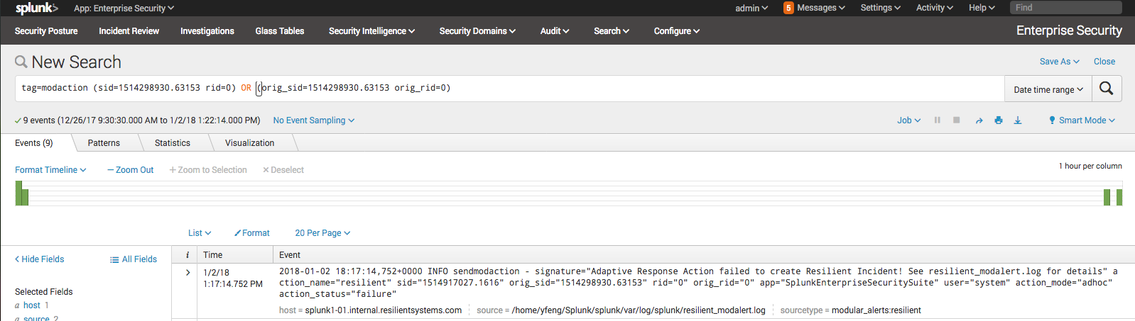
You can then open $SPLUNK_HOME/var/log/qradar_soar_modalert.log to look for details about the failure.

If the Splunk UI dispatches an error in the UI during an adhoc invocation that reads:

“SA_QRadar_SOAR could not be dispatched: ModularActionException: Invalid parameter for adhoc modular action”

It is likely that a .conf file has been edited by a person or app other than SA_QRadar_SOAR. To resolve this issue, try running the setup process for SA_QRadar_SOAR again. If the manual action still fails to complete after re-running the setup process, you may need to manually delete all entries in
$SPLUNK_HOME/etc/apps/SA_QRadar_SOAR/local/alert_actions.conf and run the setup process one more time to bring in the SOAR field definitions from scratch.
Splunk Enterprise Security 8.3.0 Compatibility

Important: This version includes a workaround for Splunk Enterprise Security 8.3.0
compatibility. ES 8.3.0's new Detection Editor uses a different rendering system that
does not automatically display complex multi-field parameters. This is not the final
polished solution but provides immediate functionality while maintaining full backward
compatibility.

Background
ES 8.3.0's Detection Editor dynamically generates UIs from configuration metadata and
cannot automatically render the three separate artifact fields (Type, Value, Description)
that were visible in previous versions. This workaround consolidates these fields into
a single pipe-delimited format that ES 8.3.0 can display.

Artifact Configuration in ES 8.3.0 Detection Editor
When configuring alerts in the ES 8.3.0 Detection Editor, use the pipe-delimited format:

Format: type|value|description
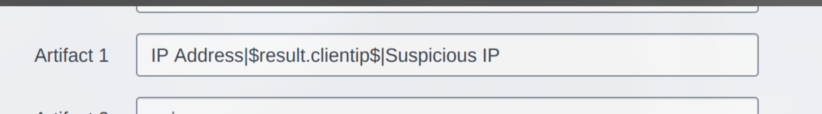
Examples:
- IP Address|192.168.1.100|Suspicious source IP
- Email Address|user@example.com|Phishing sender
- IP Address|$src_ip$|Source IP from failed login attempts

Note: This format requires manual entry. There is no dropdown or helper UI in ES 8.3.0.

Artifact Configuration in Standard Splunk Interface(Search & Reporting)
When configuring alerts in the standard Splunk interface(Search & Reporting), continue using the three
separate fields as before:
- Artifact Type (dropdown)
- Artifact Value (text field)
- Artifact Description (text field)

Backward Compatibility
- Existing alerts with separate fields continue working without modification
- New alerts can use the pipe-delimited format in ES 8.3.0
- No migration is required for existing configurations
- Both formats can be used simultaneously

Known Limitations
1. Manual Format Entry: Users must manually enter the pipe-delimited format in ES 8.3.0
2. Pipe Character Conflicts: If an artifact value contains a pipe character, use the
separate fields format in standard Splunk interface(Search & Reporting) instead
3. ES Detection Editor Only: The consolidated format is primarily for ES 8.3.0 Detection
Editor; standard Splunk interface(Search & Reporting) still shows separate fields

Support
For additional support, go to https://ibm.com/mysupport.
Including relevant information will help us resolve your issue:

- version of Splunk / Splunk Cloud
- version of Enterprise Security Add-On
- version of QRadar SOAR Add-on for Splunk
- if using Splunk 8 - which Python interpreter your server is using
- steps/screenshots that will help us reproduce your issue

Including log files located in $SPLUNK_HOME/var/log/splunk:

- splunkd.log
- python.log
- qradar_soar_config_handler.log
- qradar_soar_modalert.log

